GLOBAL SUPERSTORE SALES & PROFIT ANALYSIS
Power BI Project
Report Name: Mathew Kelly Aghelegin
Date: November 2026
DATA SELECTION:
Dataset Chosen: Global Superstore Dataset
I selected the Global Superstore dataset from Kaggle. I chose it because it is a well-known, publicly available retail dataset based on real superstore operations. It is credible, complete, and rich enough for end-to-end analysis in Power BI.
The dataset contains 51,290 order lines. Each row is one product sold in one order. It covers 147 countries, 3 Categories, 17 Sub-Categories, and 3 Customer Segments.
The context is global retail sales. The key columns are Sales, Profit, Quantity, Discount, Shipping Cost, Order Date, Ship Date, Customer, and Location. This allows me to investigate what drives profit and what destroys it.
My Analytical Questions:
- Which categories and sub-categories are most profitable?
- How does discount affect profit?
- Which regions and customer segments perform best
- How has sales trended over time?
My Hypothesis: High discounts increase sales but destroy profit, especially in Furniture and Office Supplies.
DATA EXPLORATION:
Shape of Data:
- Rows: 51,290 order lines
- Columns: 27 columns originally, 23 columns after cleaning
- Years covered: 2011 – 2014
- Missing values: 0% - All columns show 100% Valid, 0% Error, 0% Empty in Power Query

Variable Types:
- Numerical (Measures): Sales, Profit, Quantity, Discount, Shipping Cost
- Categorical (Dimensions): Category, Sub-Category, Segment, Region, Market, Ship Mode, Order Priority, Country, City, State
- Date: Order Date, Ship Date
Key Distributions & Patterns Found:
- Category: Office Supplies has the most orders, but Technology has the highest profit.
- Sub-Category: Phones, Chairs and Storage are top sellers. Tables and Bookcases make high sales but low or negative profit.
- Segment: Consumer is the biggest segment, followed by Corporate and Home Office.
- Profit Outliers: Profit ranges from a large loss of about -$6,599 on a single line to a large profit of about +$8,399. This shows some orders are heavily loss-making.
- Discount: Most orders have 0% to 20% discount. Orders with high discount (30%+) are mostly loss-making.
- Geography: United States has the highest sales. 147 distinct countries are present.
- Shipping Cost: Min 0.002, Max 933.57, Average 26.37, Standard Deviation 57.29. This shows huge variation - some orders cost almost nothing to ship, others cost over $900.
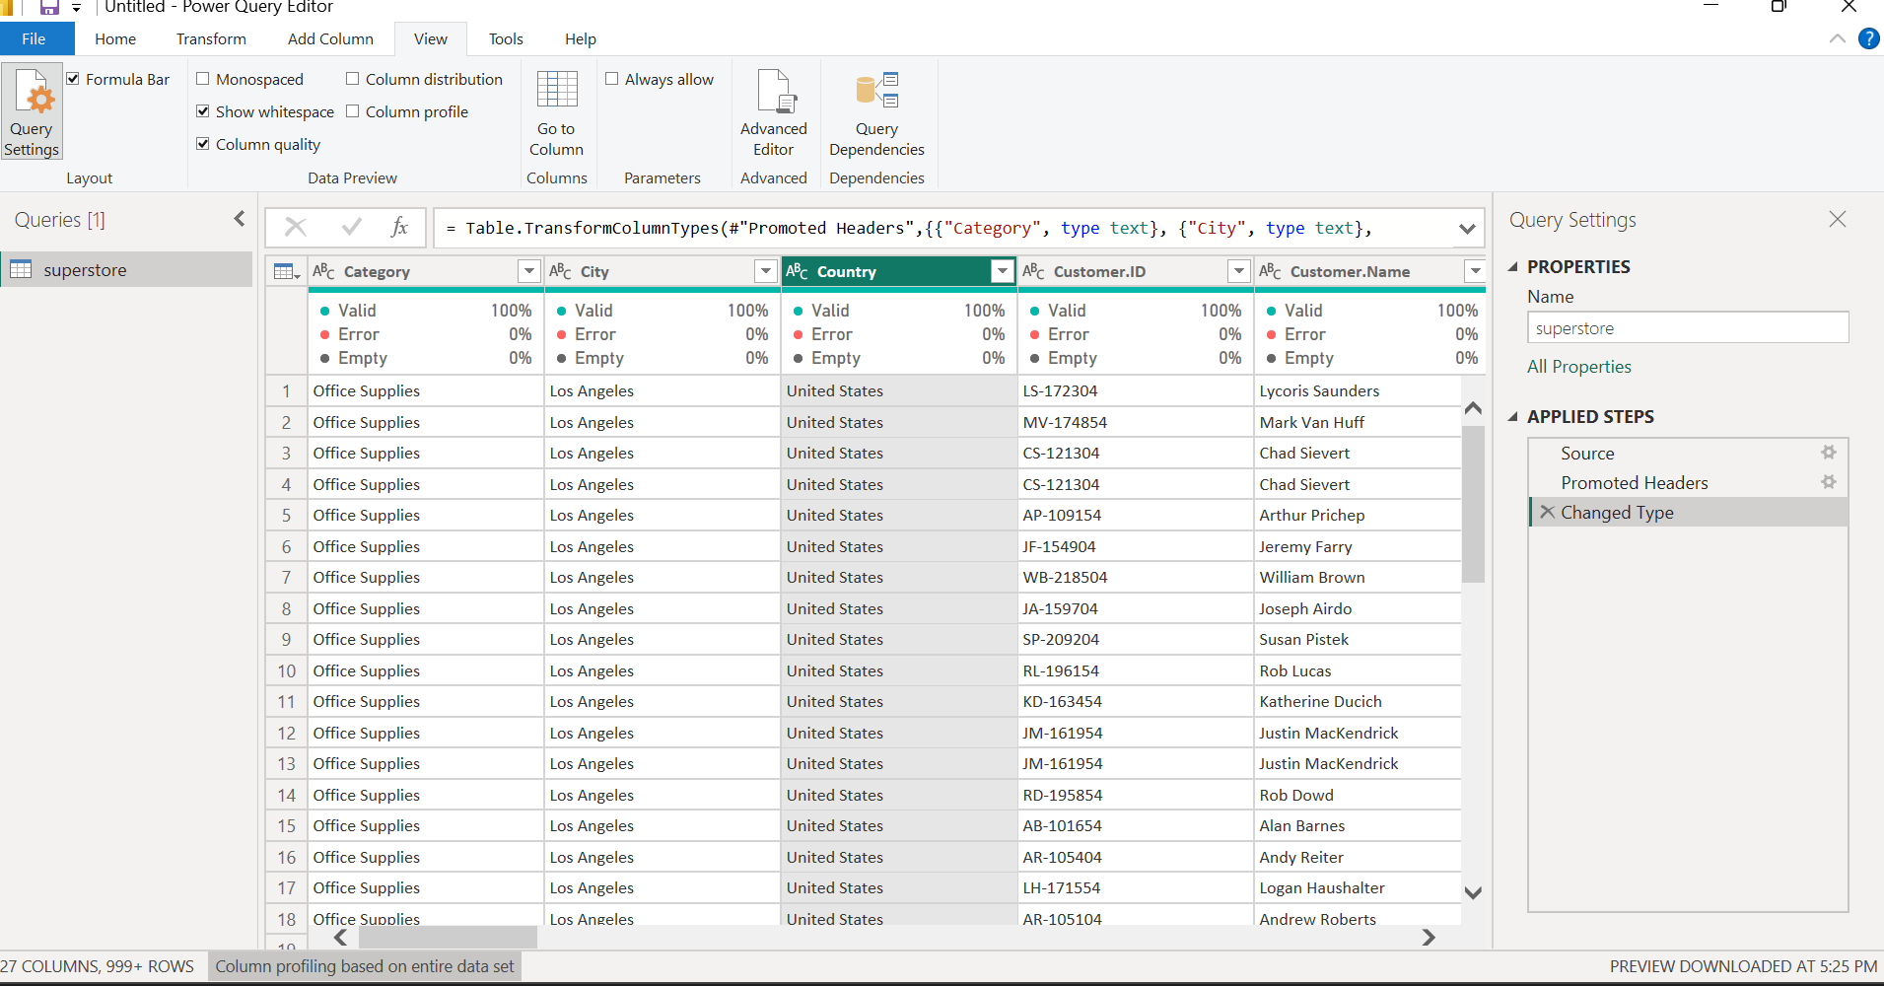
DATA CLEANING AND PREPARATION:
I did all cleaning in Power Query Editor. My final Applied Steps panel is shown in the screenshot below.
- Source - Loaded the superstore Excel / CSV file.
- Promoted Headers - First row promoted to become column headers.
- Set Types - Power BI auto-detected types.
- Changed Type with Locale - Changed Order Date to Date type using Locale English (United States). This was needed because dates were stored as text like "3/29/2016" and "Tuesday, March 29, 2016".Changed Type with Locale1 - Changed Ship Date to Date type using the same Locale method.
- Removed Columns - Removed the Chinese column 记录数 (Record Count) which was all 1s and useless.
- Renamed Columns - Renamed columns for readability. Example: Ship.Date -> Ship Date, Ship.Mode -> Ship Mode, Sub.Category -> Sub Category. Removed dots and made names clean.
- Removed Duplicates - Used Remove Duplicates on the whole table to ensure no duplicate order lines remained.
- Removed Column1 - Removed second set of unnecessary columns including Market2 which was a duplicate of Market. Columns went from 24 to 23.
- Removed Column - Customer Name: I also removed the Customer Name column. I kept Customer ID because Customer ID is unique and is enough to identify each customer and count distinct customers. Customer Name is redundant, it adds no analytical value, and it is also personal data. Removing it reduces the file size and protects customer privacy, while keeping Customer ID allows me to still analyse by customer if needed.
- Changed Type - Final type check. Changed Year to Whole Number (Int64.Type) and weeknum to Whole Number. Ensured Profit, Quantity, Sales were Decimal / Whole Number correctly. Formula in bar: Table.TransformColumnTypes(#"Removed Columns1",{{"Year", Int64.Type}, {"weeknum", Int64.Type}})
- Added Custom - Profit Margin - Created new column: Profit Margin = [Profit] / [Sales]
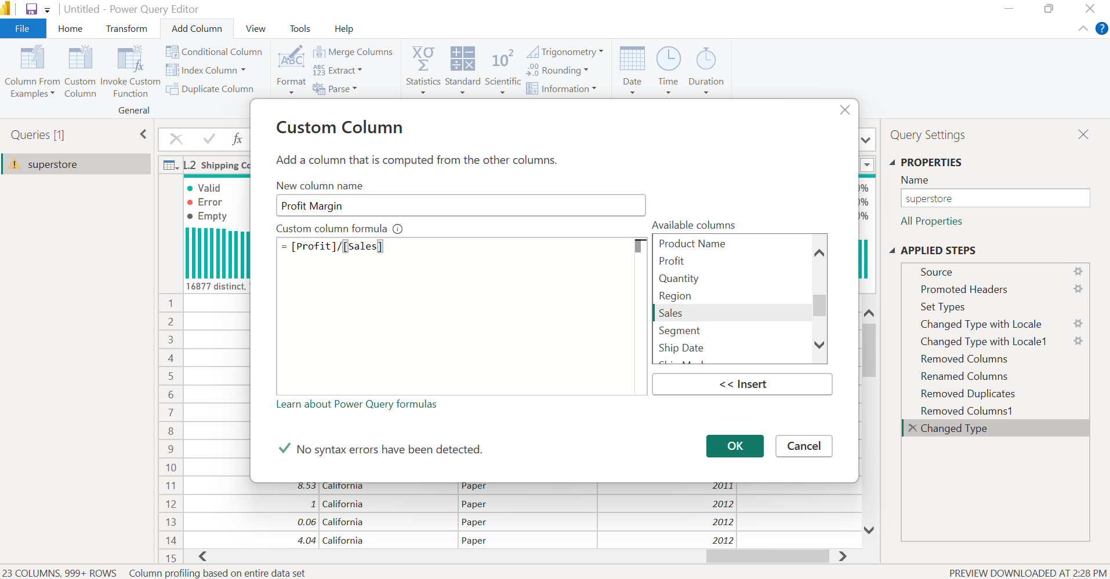
- Changed Type1 - Changed Profit Margin to Decimal Number type.
- Added Custom1 - Shipping Days - Created new column: Shipping Days = Duration.Days([Ship Date] - [Order Date])
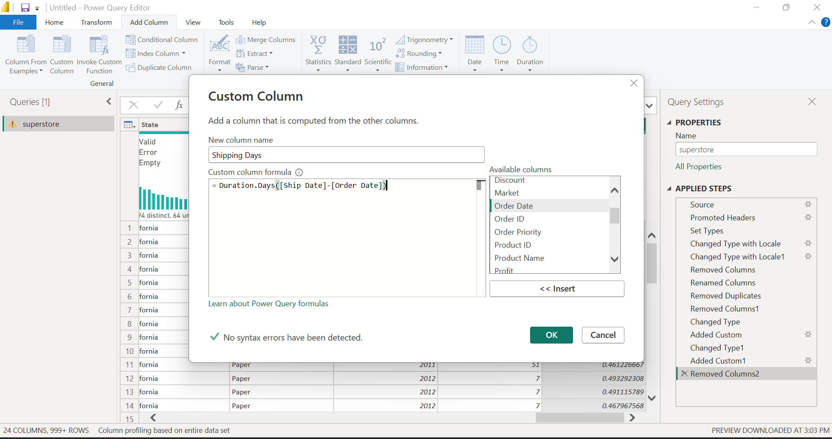

- Removed Columns2 - Removed a temporary / duplicate column created during the custom column steps. Columns went from 24 back to 23.
- Added Custom2 - Added a third custom column (Year extraction / helper) as shown in the final Applied Steps list.
- Changed Type2 - Final type check on the new custom columns to Decimal / Whole Number.
- Sorted Rows - Sorted rows by Sales in Descending Order to easily see highest sales and biggest loss orders at the top for exploration. Formula in bar: Table.Sort(#"Changed Type",{{"Sales", Order.Descending}}). In another view I also sorted by Shipping Cost descending to check shipping outliers.
Data Quality After Cleaning:
After all steps, every column shows 100% Valid, 0% Error, 0% Empty. Examples from my screenshots:
- Quantity: 100% Valid, 17292 unique, 14 distinct
- Region: 100% Valid, 13 distinct
- Sales: 100% Valid, 2246 distinct, 678 unique
- Segment: 100% Valid, 3 distinct
- Ship Date: 100% Valid, 1464 distinct
- Shipping Cost: 100% Valid, 16877 distinct, 10943 unique, Min 0.002, Max 933.57, Average 26.37, Standard Deviation 57.29
- State: 100% Valid, 1094 distinct
- Sub Category: 100% Valid, 17 distinct
- Ship Mode: 100% Valid, 4 distinct
No missing values needed to be filled. No errors needed to be replaced.
Note on Row Count: Power Query footer shows "23 COLUMNS, 999+ ROWS" because it only shows a 1,000-row preview. Column profiling is based on the entire dataset (51,290 rows). The full data is loaded when I click Close & Apply.
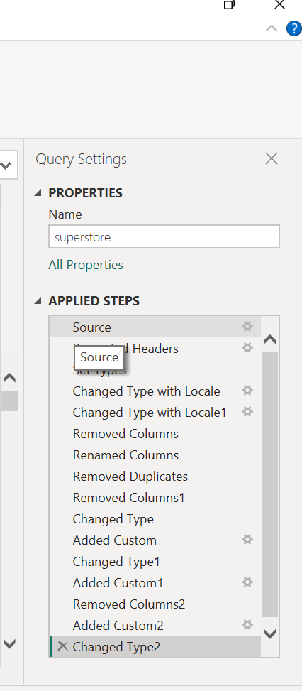
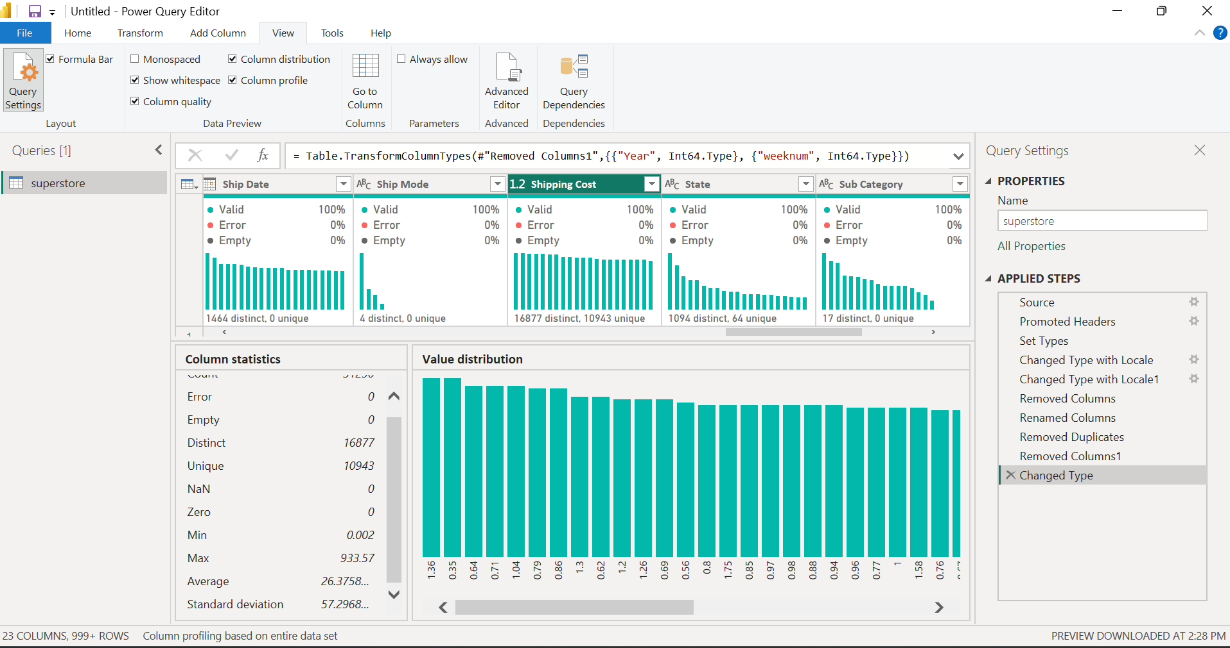

VISUALIZATION DESIGN:
I created the following charts in Power BI. I chose each chart type for a specific reason:
- KPI Cards (Total Sales, Total Profit, Average Discount, No of Orders, Total Quantity): To give an instant summary. Total Sales ∼$12.64M, Total Profit ∼$1.47M for all years.
- Bar Chart - Profit by Category: Bar is best for comparison. Shows Technology > Office Supplies > Furniture.
- Bar Chart - Profit by Sub-Category: Shows Copiers, Phones, Accessories at top, and Tables, Bookcases, Supplies at bottom (negative). This is my key insight.
- Bar Chart - Profit & Sales by Market: Shows which market contributes most.
- Map - Sales by Country: Map is best for location. Shows US is darkest / biggest, with sales across 147 countries.
- Scatter / Column - Discount & Profit by Sub-Category: Scatter is best for relationship. Shows as discount goes up, profit goes down.
- Pie Chart - Sales by Segment: Pie is best for share. Shows Consumer is biggest share.
- Column Chart - Sales & Profit by Year: Column/Line is best for trend over time 2011-2014. Shows growth.
Colour: I used a consistent pink / deep blue & light blue so all charts look like one dashboard, with clear titles and data labels
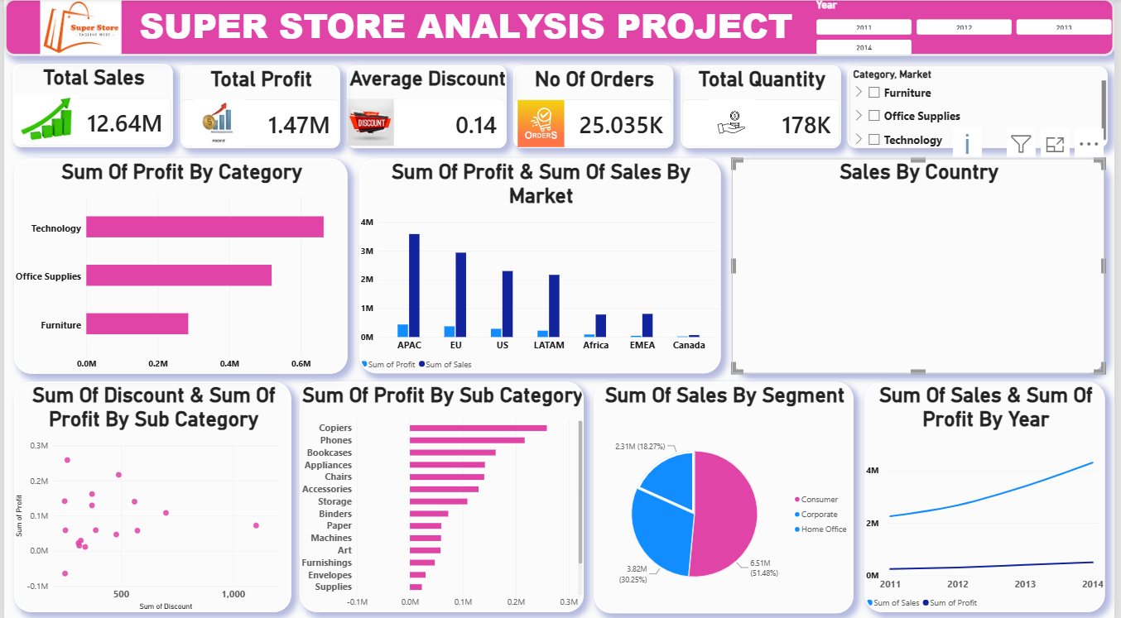

INTERACTIVE DASHBOARD:
My dashboard is on one page and is fully interactive
Layout:
- Top: 5 KPI Cards (Total Sales, Total Profit, Average Discount, No of Orders, Total Quantity)
- Top Right: Two Slicers
- Year Slicer - to filter for the year (2011, 2012, 2013, 2014)
- Category and Market Slicer - to filter for Category (Furniture, Office Supplies, Technology) and Market (US, EU, Asia Pacific, etc.)
- Middle: Profit by Category, Profit & Sales by Market, Sales by Country Map
- Bottom: Discount & Profit by Sub-Category, Profit by Sub-Category, Sales by Segment, Sales & Profit by Year
Interactivity - How it works:
- Year Slicer: If I click Year = 2014, ALL charts on the page filter instantly to show only 2014 data. The KPI cards, bar charts, map and trend chart all change together.
- Category and Market Slicer: If I click Category = Furniture, ALL charts filter to show only Furniture. If I then click Market = US, it filters further to show only Furniture sold in the US market. This shows the power of combining slicers.
- Cross-filtering: If I click the "Technology" bar in Profit by Category, the Map, the Segment pie, and the Year chart all highlight only Technology data, without using a slicer.
- Tooltips: Hovering over any bar or dot shows the exact Sales and Profit value.
Proof that it works - My 2 Screenshots:
- First screenshot: Dashboard filtered with Year Slicer = 2014 and Category Slicer = Furniture. Total Sales 1.38M, Total Profit only 89.31K, Average Discount 0.17, No of Orders 2.772K, Total Quantity 12K. Tables sub-category shows negative profit.
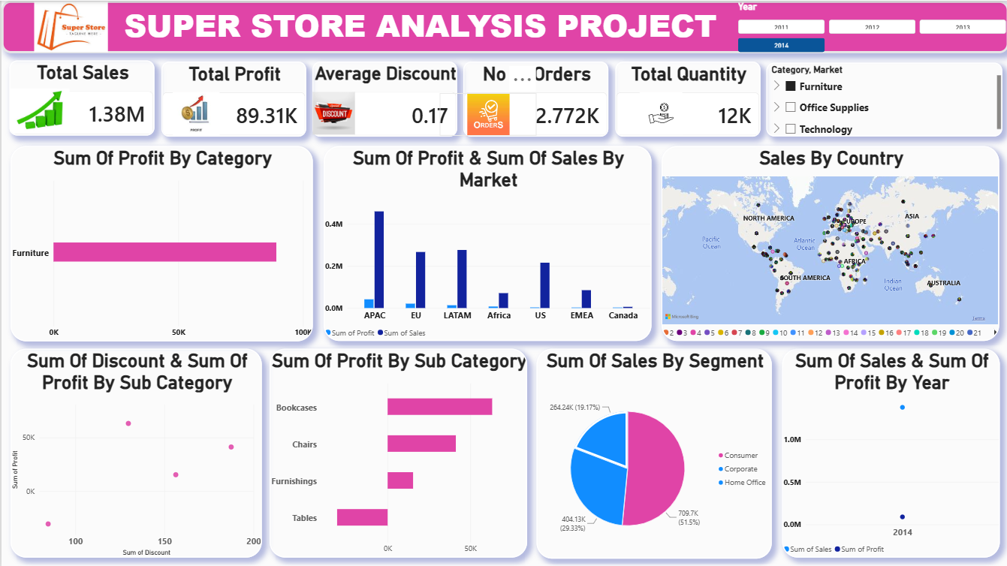

- Second Screenshot: Dashboard filtered with Year Slicer = 2014 and Category Slicer = Technology. Total Sales 1.62M, Total Profit 234.93K, Average Discount 0.13, No of Orders 2.842K, Total Quantity 12K. All sub-categories (Copiers, Phones, Accessories, Machines) are profitable.
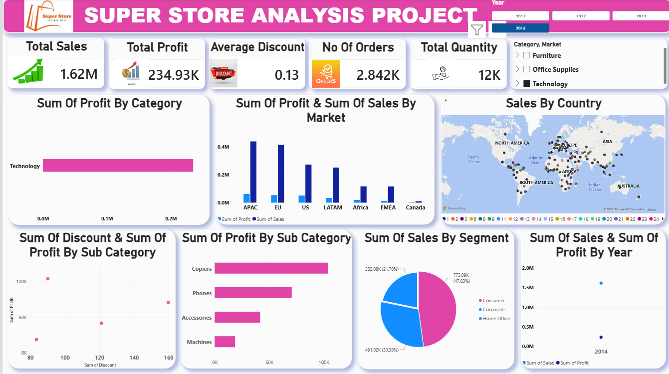
KPI (Year = 2014) | Furniture (Screenshot 1) | Technology (Screenshot 2)
Total Sales | 1.38M | 1.62M
Total Profit | 89.31K | 234.93K
Average Discount | 0.17 | 0.13
No of Orders | 2.772K | 2.842K
Total Quantity | 12K | 12K

This proves the dashboard is not a static picture - it is interactive. The slicers change every KPI and every chart at the same time.
STORYTELLING:
The Superstore is growing in sales, but not in profit.
Technology is carrying the business. Phones, Copiers and Accessories make the most profit. Office Supplies sells the most units, but makes less profit per unit.
Furniture is the problem. Tables and Bookcases have high sales but make a loss. The reason is discount. The dashboard shows that when discount is high, profit becomes negative.
The slicer comparison proves my hypothesis. In 2014, Furniture and Technology both sold 12K quantity, but Technology made 234.93K profit while Furniture made only 89.31K. The difference is discount - Furniture had 0.17 average discount, Technology had 0.13. Technology made 2.6x more profit than Furniture in the same year, with almost the same quantity.
The recommendation is simple: Stop giving deep discounts on Furniture, especially Tables and Bookcases. Review shipping costs for loss-making products, and focus promotions on high-margin Technology. If management continues the current discount strategy, sales will look good but profit will keep falling.
REFLECTION AND LIMITATIONS:
I chose Power BI because it allows cleaning in Power Query, DAX calculations, and interactive dashboards in one tool, without needing separate Excel and presentation software.
The main challenge was cleaning dates. Order Date and Ship Date were stored as text in different formats, so I had to use "Change Type with Locale" with English (United States) to convert them correctly to Date.
Another challenge was understanding why some products were loss-making. Sorting by Sales and Shipping Cost in Power Query helped me see the biggest losses and most expensive shipping clearly.
Limitation: The data ends in 2014, so it may not reflect current retail trends, prices, or customer behavior in 2026. It also does not show marketing cost or customer satisfaction.
What I learned: High sales does not mean high profit. Visualization makes this clear to non-technical managers - one bar chart of Profit by Sub-Category tells the story faster than a table of 51,290 rows.

